Mid (22-23)

1.
a)
What is wrong in the following code?
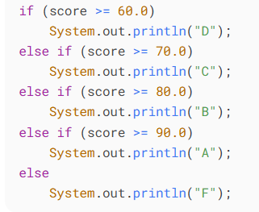
b)
What is y after the following switch statement is executed?
Rewrite the code using an if-else statement.
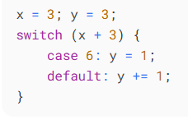
c)
Analyze the following code. Is count < 100 always true, always false, or sometimes true or sometimes false at Point A, Point B, and Point C?
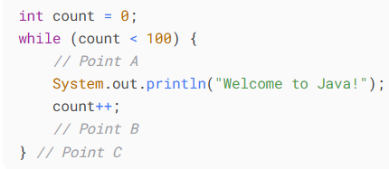
d)
After the break statement in (i) is executed in the following loop, which statement is executed? Show the output.
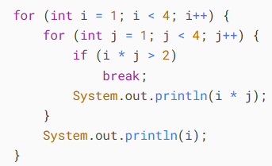
Sol^{n}:
- The conditions are written in the wrong order.
For example, if score = 95, the first condition score >= 60.0 is already true, so "D" will print, and the rest will never be checked.
- Explanation:
x = 3, so x + 3 = 6.
Enters case 6: → sets y = 1.
No break statement, so it “falls through” to default.
In default: y += 1 → y = 1 + 1 = 2.
Final value: y = 2
Equivalent if-else:
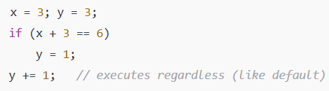
- Explanation:
At Point A:
Loop condition guarantees that the code inside runs only if count < 100.
So count < 100 is always true at Point A.
At Point B:
After increment: count++.
- When count = 99, after increment it becomes 100. At that moment, count < 100 is false.
- Otherwise (for 0 to 98), it’s still true.
So sometimes true, sometimes false at Point B.
At Point C:
Loop exits when count < 100 becomes false.
That happens only when count == 100.
So always false at Point C.
- Step-by-step (dry run):
- Outer loop i = 1
  - j = 1 → 1*1=1 ≤ 2 → print 1
  - j = 2 → 1*2=2 ≤ 2 → print 2
  - j = 3 → 1*3=3 > 2 → break (exit inner loop)
  - After break → control goes to next statement after inner loop, i.e. System.out.println(i);
  - Prints 1
- Outer loop i = 2
  - j = 1 → 2*1=2 ≤ 2 → print 2
  - j = 2 → 2*2=4 > 2 → break
  - After break → prints i → 2
- Outer loop i = 3
  - j = 1 → 3*1=3 > 2 → break immediately
  - After break → prints i → 3
Output:
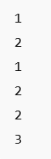

1.
e) Write a Java application that calculates and prints the sum of the integers from 1 to 20. Use a while statement to loop through the calculation and increment statements. The loop should terminate when the value of i becomes 21.
Sol^{n}:
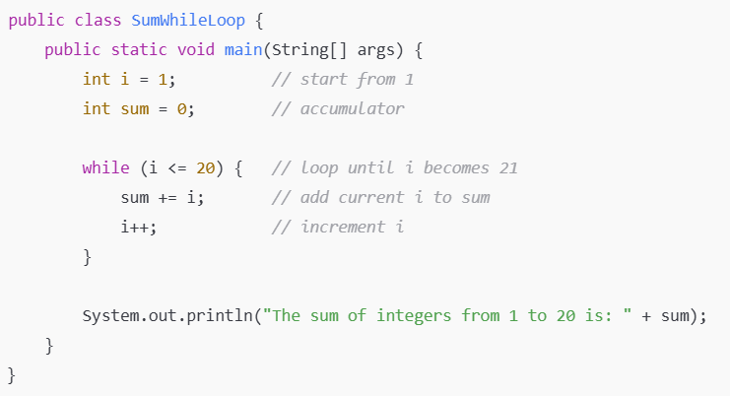

1. f)
i) Java programs normally go through five phases: _________, _________, _________, _________ and _________.
ii) Java programmers concentrate on creating _________, which contain fields and the set of methods that manipulate those fields and provide services to clients.
iii) Keyword _________ requests memory from the system to store an object, then calls the corresponding class's constructor to initialize the object.
iv) All programs can be written in terms of three types of control structures: _________, _________ and _________.
Sol^{n}:
i) Java programs normally go through five phases: edit, compile, load, verify and execute.
ii) Java programmers concentrate on creating classes, which contain fields and the set of methods that manipulate those fields and provide services to clients.
iii) Keyword new requests memory from the system to store an object, then calls the corresponding class's constructor to initialize the object.
iv) All programs can be written in terms of three types of control structures: sequence, selection and iteration.

2.
a) What is invoked first, instance initializer block or constructor? Justify your answer with example.
Sol^{n}:
Already solve.

2.
b) What is blank final variable? Can we initialize it? How? Give example.
Sol^{n}:
Already solve.

2.
b) Will the following code be successfully compiled? If yes, what is the output? Give a brief explanation of the result.
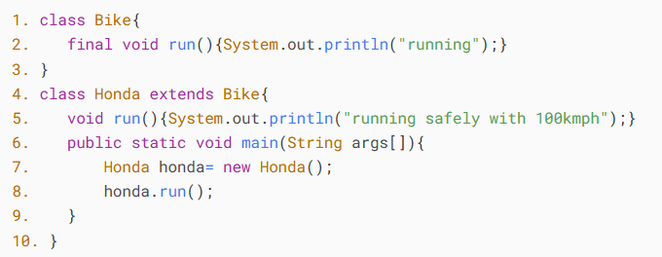
Sol^{n}:
Compilation:
- In Bike, the method run() is declared final → meaning it cannot be overridden in a subclass.
- In Honda, line 5 tries to override run().
- This is not allowed, so the compiler will throw an error.
Result:
The code will NOT compile.
Error message (approximate):
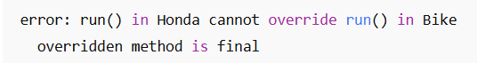
The code will not compile because the subclass Honda attempts to override the final method run() from class Bike.

